ANSWERS

Section A

Question 1 (8 marks)
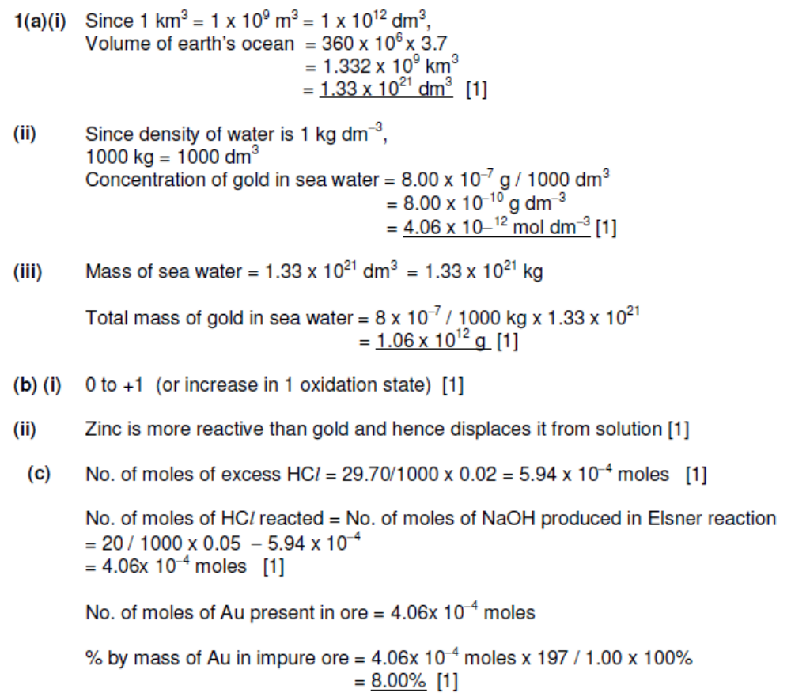

Question 2 (4 marks)

2. |  | (i) | K_{a} increases increasing number of Cl substituents  Both CH₂ClCOOH and CHCl₂COOH has electron-withdrawing Cl atom which disperse the negative charge on O atom on the RCOO⁻/ carboxylate anion, making CH₂ClCOO⁻ and CHCl₂COO⁻ more stable than CH₃COO⁻.  CHCl₂COOH has one more electron-withdrawing Cl atom than CH₂ClCOOH, dispersing the negative charge on O atom to a larger extend / more, making CHCl₂COO⁻ more stable than CH₂ClCOO⁻
 |  | (ii) | Benzoic acid is more acidic than ethanoic acid  The negative charge on the COO⁻ group of the benzoic acid can be delocalised into the π system of the benzene ring / benzene ring, dispersing the negative charge on the COO⁻ anion, making the benzoate anion more stable than CH₃COO⁻ .

Question 3 (4 marks)

3 (i) Number of moles of propan-1-ol burnt = 0.60 / [3(12.0) + 8(1.0) + 16.0)]
= 0.0103 mol

- Let the final temperature be T°C

Amount of heat liberated from combustion = 0.010 x 2021
= 20.21 kJ

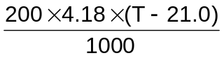 = 20.21

T = 45.1°C

(iii) Heat loss to surroundings or incomplete combustion of propan-1-ol resulting in less heat produced.

Question 4 [5 marks]

(i) Write the equation which corresponds to the standard enthalpy change of formation of chlorine trifluoride.
½Cl₂(g) + 3/2F₂(g) → ClF₃(g)
(ii) Some standard enthalpy changes are given below:
Enthalpy change of formation of AlF₃(s) | -1350 kJ mol⁻¹
Enthalpy change of combustion of Al(s) | -840 kJ mol⁻¹

Using the data given in the question, calculate the enthalpy change of formation of chlorine trifluoride.

ΔH_{f}(Al₂O₃) = 2 ΔH_{c}(Al) = 2(-840) = -1680 kJ mol⁻¹

ΔH_{r} = ∑( ΔH_{f})_{products} - ∑( ΔH_{f})_{reactants}
-1420 = 4(-1350) - 4 (ΔH_{f})_{ClF3} – 2(-1680)

(ΔH_{f})_{ClF3} = -155 kJ mol⁻¹

(iii) Using your answer in d(ii) and data from the Data Booklet, estimate the average bond energy of the Cl-F bond.

Consider ½ Cl₂(g) + 3/2 F₂(g) → ClF₃(g)
From the Data Booklet, B.E. of Cl–Cl = 244, F–F = 158
-155 = ∑( B.E.)_{reactants} - ∑( B.E.)_{products}
= ½ (244) + 3/2(158) – 3 B.E.(Cl–F)
B.E. (Cl–F) = 171 kJ mol⁻¹

Question 5 (7 marks)

ANSWERS
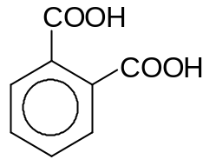
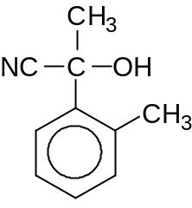
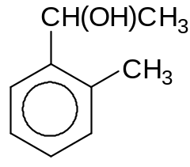
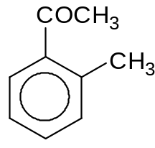
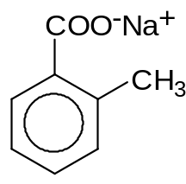
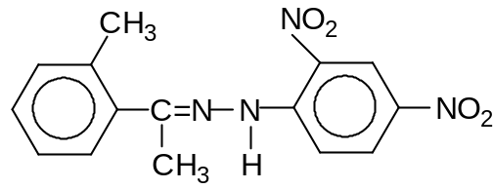
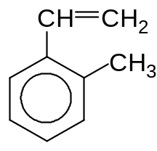
2,4–DNPH
C₈H₇O₂Na

E
Step II
Oxidation

B
C₉H₁₀
C₉H₁₂O

A

Step I
H₂SO₄, K₂Cr₂O₇,

heat
C₉H₁₀O

C
Step III
I₂, NaOH, warm
I₂, NaOH, warm
C₁₅H₁₄N₄O₄

D

 | Reagents & Conditions
Step I | KMnO₄, H₂SO₄, heat
Step II | Excess conc.H₂SO₄, 170 ºC
Step III | HCN, small amt of KCN, 10 to 20ºC

Question 6 [12 marks]

ANSWERS

(a)

Al
- Giant metallic structure with strong electrostatic force of attraction between the metal cation and the sea of delocalized mobile electrons. Large amount of energy is required to break the strong metallic bonds, hence high m.p.

Silicon
  - Giant molecular structure with numerous strong covalent bonds holding the Si atoms in a tetrahedral manner. Large amount of energy required to break these numerous strong covalent bonds, hence high m.p.

Phosphorus P₄
  - Simple molecular structure with weak VDW holding the discrete molecules. Ar exist as a monoatomic gas. Small amount of energy required to break these VDW forces; hence the m.p is generally low.

(b)

AlCl₃(s) + 6H₂O → [Al(H₂O)₆]³⁺(aq) + 3Cl⁻(aq)
[Al(H₂O)₆]³⁺(aq) → [Al(H₂O)₅(OH)]²⁺(aq) + H⁺(aq)

SiCl₄(l) + 2H₂O(l) → SiO₂(s) + 4HCl(aq)
PCl₅(s) + 4H₂O(l) → H₃PO₄(aq) + 5HCl(aq)

6c)
N
H
H
H
XX
(trigonal pyramidal, 107º)

[1 for shape, bond angle and dot & cross diagram]

(bent shape, 105º)
N
XX
X
H
H

[1 for shape, bond angle and dot & cross diagram]

N
H
H
H
H
XX
- (tetrahedral, 109º)

- Note: Nitrogen forms a dative bond with H^{+.}
- Once a dative bond is formed, it is treated like a normal covalent bond.

Section B

Question 1
ANSWERS
(a) | (i)  [Compound X]/ mol dm⁻³ | 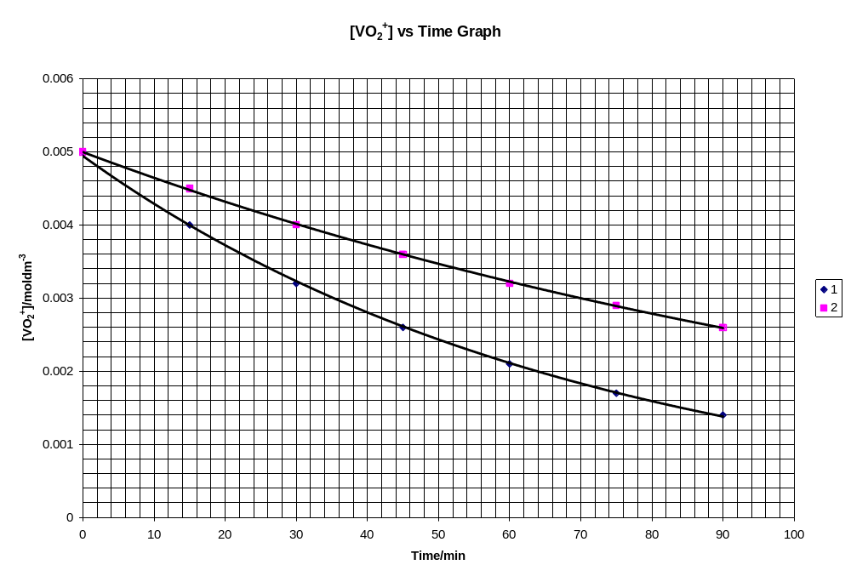  [Compound X] VS Time
 | (ii) | From the graph (experiment 1):  1st t = 48.5 min  2nd t = 48.5 min  3rd t = 49.5 min (show two constant t will do)  show either annotation on graph  or indicate constant t in working  - Since the 3 half-lives are constant, the order of reaction with respect to Compound X is 1.  Initial rate for Expt 1  = 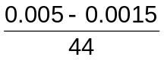  = 7.95 × 10⁻⁵ mol dm⁻³ min⁻¹  Initial rate for Expt 2  = 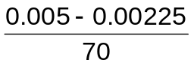  = 3.93 × 10⁻⁵ mol dm⁻³ min⁻¹  - When [H⁺] is halved, the initial rate is also halved. The order of reaction with respect to H⁺ is 1.  - Hence the rate equation:  rate = k [Compound X] [H⁺]
 | (iii) | rate = k [Compound X] [H⁺]  - 7.95 x 10⁻⁵ = k x 0.0050 x 0.10  - k = 0.159 mol⁻¹ dm³ min⁻¹

1(b)
Either
Test: warm with alkaline aqueous iodine
Observation: compound C will form a yellow ppt, CHI₃ but compound D will not form any ppt.

Or
Test: warm with acidified K₂Cr₂O₇
Observation: Compound C will turn H⁺/K₂Cr₂O₇ from orange to green but no colour change for compound D.

(ii)
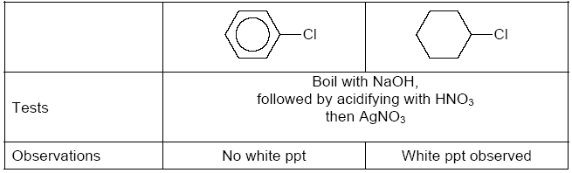

1c)
i) ethene to cyanoethane (C₂H₅CN)
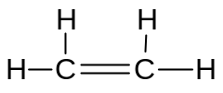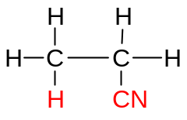

I

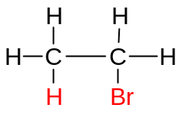
II

Step I: CH₂=CH₂ + HBr → CH₃CH₂Br
Reagents & Conditions: HBr in CCl₄

Step II: CH₃CH₂Br + KCN → CH₃CH₂CN
Reagents & Conditions: KCN in ethanol, reflux

ii) 2-bromobutane to 2-methylbutanoic acid
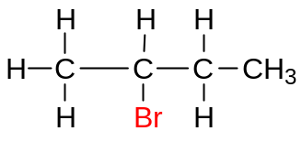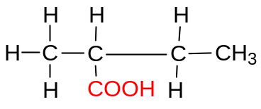

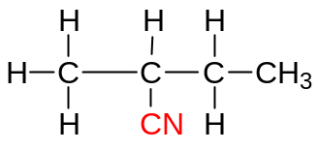
II
I

+ KBr
+ KCN

Step I:

Reagents & Conditions: KCN in ethanol, reflux

+ HCl + 2H₂O
+ NH₄Cl
Step II:

Reagents & Conditions: dilute HCl, heat OR any dilute acid, heat

Question 2

2a)
- Compound D [C₁₀H₁₁O₂Br] has comparable number of C and H atoms (C:H ratio ≈ 1:1) and number of C atoms ≥ six

⇒ D contains a benzene ring

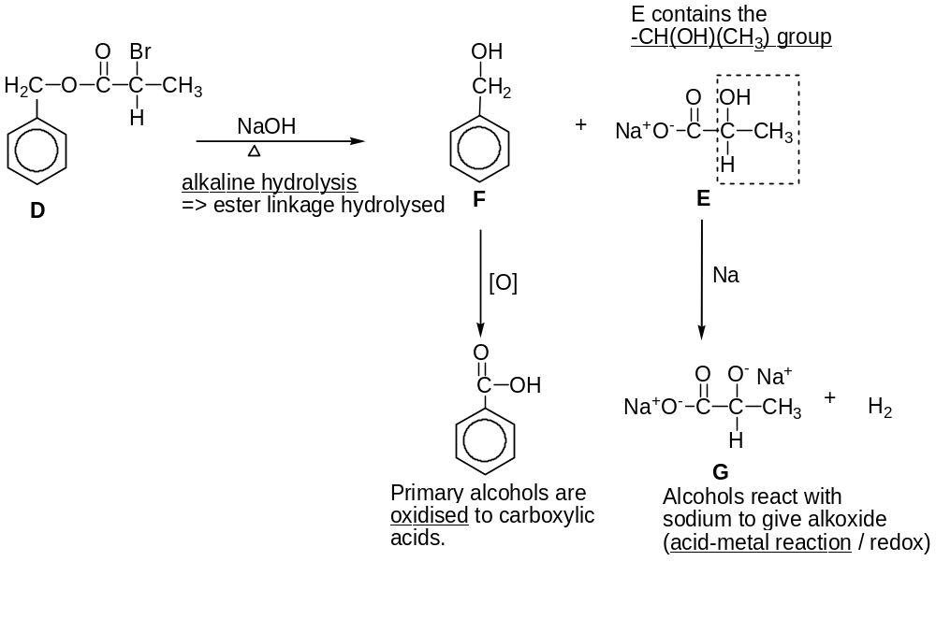

2b)

- pH = - log [H⁺]

[H⁺] = 10 ^{– 2.11}
= 7.76 x 10⁻³ mol dm⁻³

(ii) No. of moles NaOH used = (33.3/1000 x 0.150) mol
No. of moles citric acid titrated = (33.3/1000 x 0.150) mol
[citric acid] = (33.3/1000 x 0.150)/ 20.0 x 10⁻³ mol dm⁻³
[H⁺] = (33.3/1000 x 0.150)/ 20.0 x 10⁻³ mol dm⁻³
= 0.24975 mol dm⁻³
= 0.250 mol dm⁻³ (to 3 s.f.)

(iii) In part (i) [H+] is a measure of the free hydrogen ions obtained when the acid dissociates.
In part (ii) [H+] is a measure of the total concentration of hydrogen ions present in the acid.

(iv) Phenolphthalein, the working range pH of the indicator is within the pH at equivalence point.

- Ka = [citrate ion] [H+]
[citric acid]

(vi)
I. C₅H₇O₄COOH + OH– → C₅H₇O₄COO– + H₂O
OR
The added OH – ,combines with the citric acid to form citrate ion and water so change in pH is resisted.

II. C₅H₇O₄COO– + H⁺ → C₅H₇O₄COOH

OR

The added acid, H⁺, combines with the citrate ion to form the weak acid. Thus change in pH due to the addition of small amount of acid is resisted.

2(c)

Al₂O₃ is amphoteric and can thus react with both acids and bases

Al₂O₃(s) + 6H⁺(aq) → 2Al³⁺(aq) + 3H₂O(l)
Al₂O₃(s) + 2OH⁻(aq) + 3H₂O(l) → 2Al(OH)₄⁻(aq)

* SiO₂ and P₄O₁₀ are acidic oxides and thus react with bases

SiO₂(s) + 2OH⁻(aq) → SiO₃²⁻(aq) + H₂O(l)
P₄O₁₀(s) + 12OH⁻(aq) → 4PO₄³⁻(aq) + 6H₂O(l)

Question 3
Answers
(a) (i) | A undergoes oxidation with K₂Cr₂O₇ to give B and C  ⇒ A contains an alcohol group  B and C undergoes oxidative cleavage with hot conc. KMnO₄  ⇒ B and C contains an alkene group (double bond)  B undergoes condensation reaction with 2,4-DNPH  ⇒ B contains a ketone/aldehyde group
A: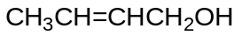

B: 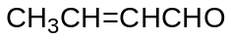

C: 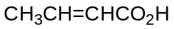

(ii) | Geometrical (cis-trans) isomerism  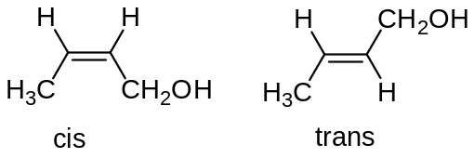

3b)

No. of moles of Fe²⁺ 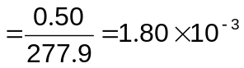moles

5Fe²⁺ ≡ MnO₄⁻

No. of moles of MnO₄⁻ 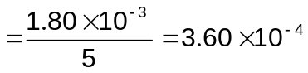moles

Volume of KMnO₄ 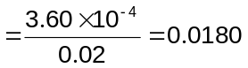 dm³ (18.0 cm³)

3c
(i)
Na₂O + 2HCl → 2NaCl + H₂O
Moles of Na₂O = 6.2 / 62.0 = 0.100 mol (limiting)
Moles of HCl = 0.250 x 1.0 = 0.250 mol (excess)
Hence, moles of H₂O produced = 0.100 mol

∆H₂ = -(0.25 x 4.18 x 17) / 0.100 = -178 kJ mol⁻¹

(ii)
Enthalpy change of neutralisation is the heat energy evolved when acid and base react to form one mole of water under standard condition of 298 K and 1 atm.

OR H⁺(aq) + OH⁻(aq) → H₂O(l)

∆H₃ = 2(-57.3) = -114.6 kJ mol⁻¹

(iii)

∆H₁ = ∆H₂ – ∆H₃ = -178 – (-115) = -63 kJ mol⁻¹

Answers
3d(i)
When temperature increased, % SO₃ at equilibrium decreases, which means backward reaction is favored.
By Le Chatelier’s Principle, when temperature increases, the equilibrium position will shift to favor the endothermic reaction to absorb heat
⇒ Backward reaction is endothermic.
⇒ Forward reaction is exothermic
Therefore the formation of SO₃ is exothermic

(ii)

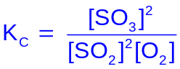

(iii)
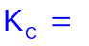[4/3]² / { (0.2/3)² (0.3/3) }
= 4000 mol⁻¹dm³

End of Paper

